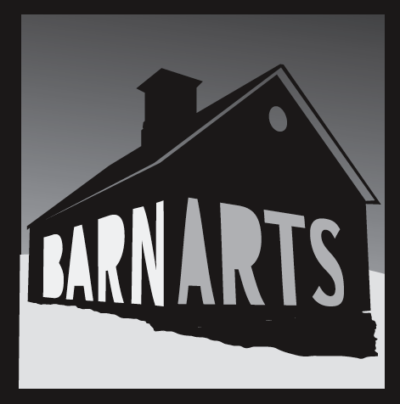

BarnArts Center for the Arts
P.O. Box 41 • Barnard, VT 05031-0041 • 802-234-1645
www.barnarts.org • info@barnarts.org

_____________________________________________________________________________________________________________

BarnArts Summer Youth Theater 2025
Matilda New Students Registration Form
Camp begins Monday, July 14
Performance weekend: Aug 1-3
Note: Returning students have priority and all registrations will be confirmed by March 1st.
New registrations are first-come-first-served. Some limitations within age ranges can occur depending on demand.

Welcome to BarnArts Summer Youth Theater 2025! Registration is limited to 30 youth ages 8-18. Please complete this form and email to info@barnarts.org. The registration fee of $550 will be due when registration is confirmed. The fee rises to $600 for applications received after April 1st.

Note: This registration form is to secure your child’s spot in line. Once space is confirmed, payment will be due and an additional participation agreement form signed. This is a full day community theater program and creating a full theatrical production from the ground up is an exciting but big commitment. Some parental involvement is required. A full registration packet with other forms and details will be available in July.

Student Information
Name:
Grade in current school year:
Gender:
Age as of July 14, 2025:
Name of School:

Parent Information
Parent Name(s): Town of Residency:

Primary emails including student (optional):

Mailing Address:

Phone Numbers:

Physical Address (if different):

Comments:

Questions? Please email Executive Director, Linda Treash, at linda@barnarts.org or call 802-234-1645.

